Lab 2: Biological Artifacts in EEG

Group Members

Name | UNI
Thomas Duan (Cap) | hd2593
Surya Shanmugam | ss7318
Zhewen Guo | zg2567

Goals
- Identify and document characteristic EEG artifacts;
- Compare monopolar and bipolar derivations for their effectiveness in suppressing EOG and EMG artifacts;
- Evaluate the reduction of 50/60 Hz power line interference based on bipolar recordings;

Experiment 1: EEG signal visualization and data storage
Surya Shanmugam

Experiment 2: Bipolar derivation
Experiment 2.1: Bipolar derivations between FC1-Fz, FC1-FC2, and FC1-Pz.
I. Blinking eyes
According to Figure 2.1.1 and 2.1.2, the average amplitude of monopolar signal is 84.82± 15.13 μV, while the amplitude with bipolar is significantly smaller. Specifically, the FC1-Fz and FC1-FC2 signals exhibit significantly fewer EOG artifacts, whereas the FC1-Pz signal shows relatively poorer performance in artifact suppression.
One possible reason for this phenomenon is that each pair of electrodes in FC1-FZ and FC1-FC2 is located in the same brain region, which helps to reduce artifacts (and signals) common to both channels​ and ​emphasize the specific voltage difference between the given positions. In contrast, the FC1-Pz pair represents a ​cross-regional connection. Different brain regions capture EEG signals with distinct properties, which may lead to the ​mixing of signals from both areas, thus making it more challenging to reduce artifacts.
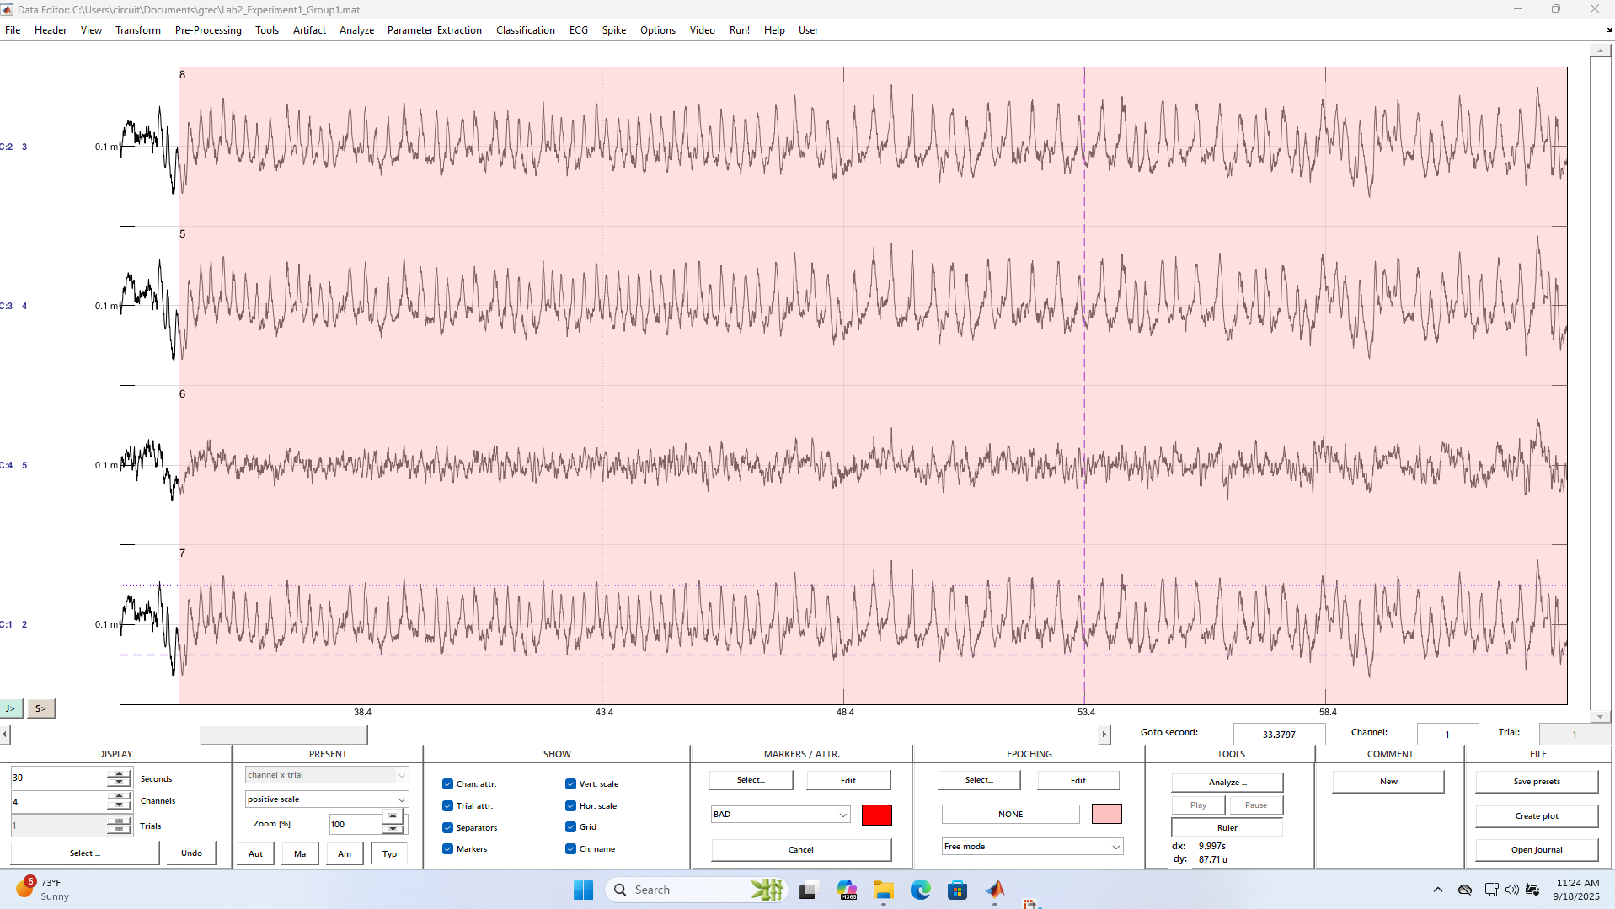
Figure 2.1.1 Eyes Blinking Monopolar
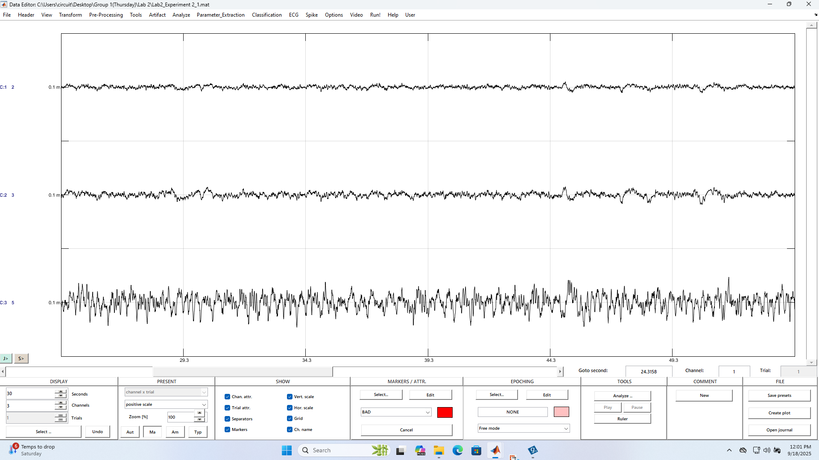
Figure 2.1.2 Eyes Blinking Bipolar Compared to Channel 3

II. Chewing
The results are quite similar to the Eyes Blinking Experiment, both the amplitude value and signal fluctuation decrease after applying a bipolar derivation. Among all three derivations tested, FC1-FZ derivation suppresses the EMG artifacts best, followed by FC1-FC2, while the performance of FC1-Pz is the worst. The reason is that FC1-FZ and FC1-FC2 derivations are located in the same brain region.
Besides, we also notice that the suppression performance of EMG is much worse than EOG, which lies on the distinct features of EMG. EMG signals are generated by the movement and contraction of muscles. EMG artifacts typically exhibit a broad frequency range (20–300 Hz) and high amplitude, characteristics that significantly reduce the signal-to-noise ratio (SNR) and complicate the separation of neural signals from artifacts. Therefore, a further process is required to remove EMG artifacts.
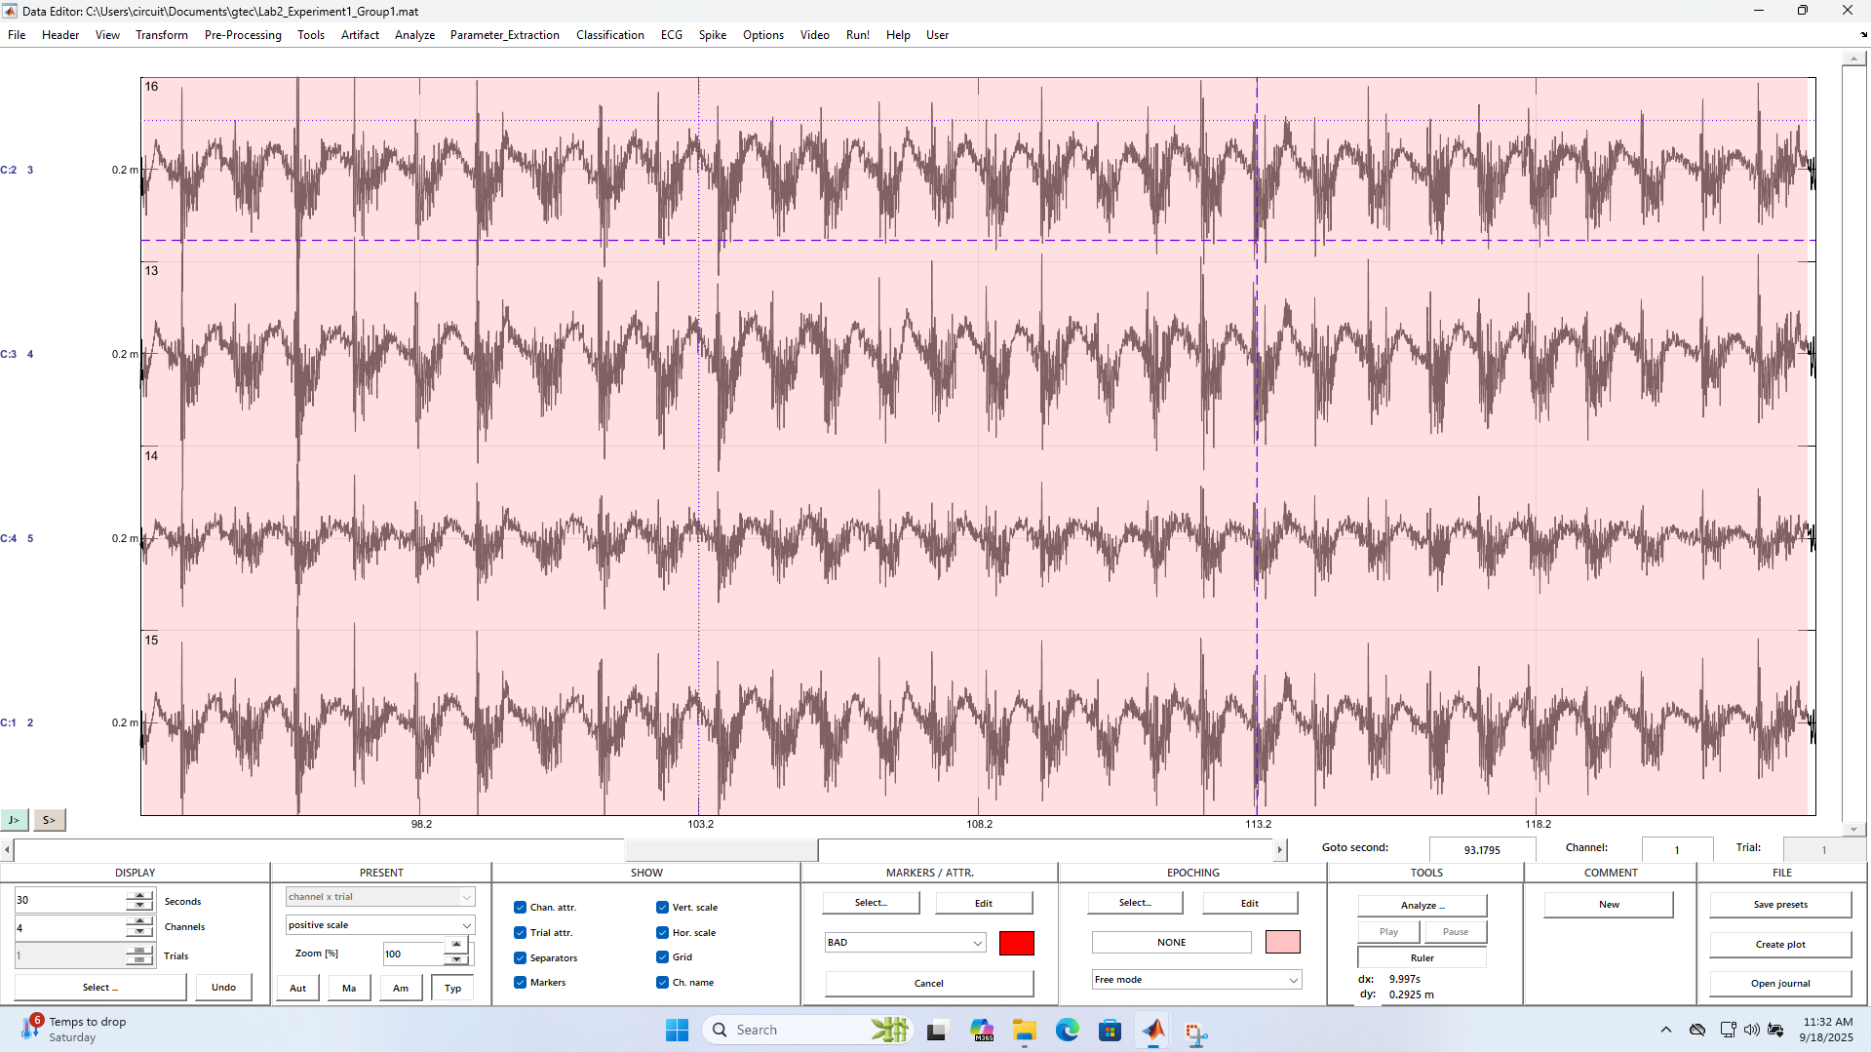
Figure 2.1.3 Chewing Monopolar
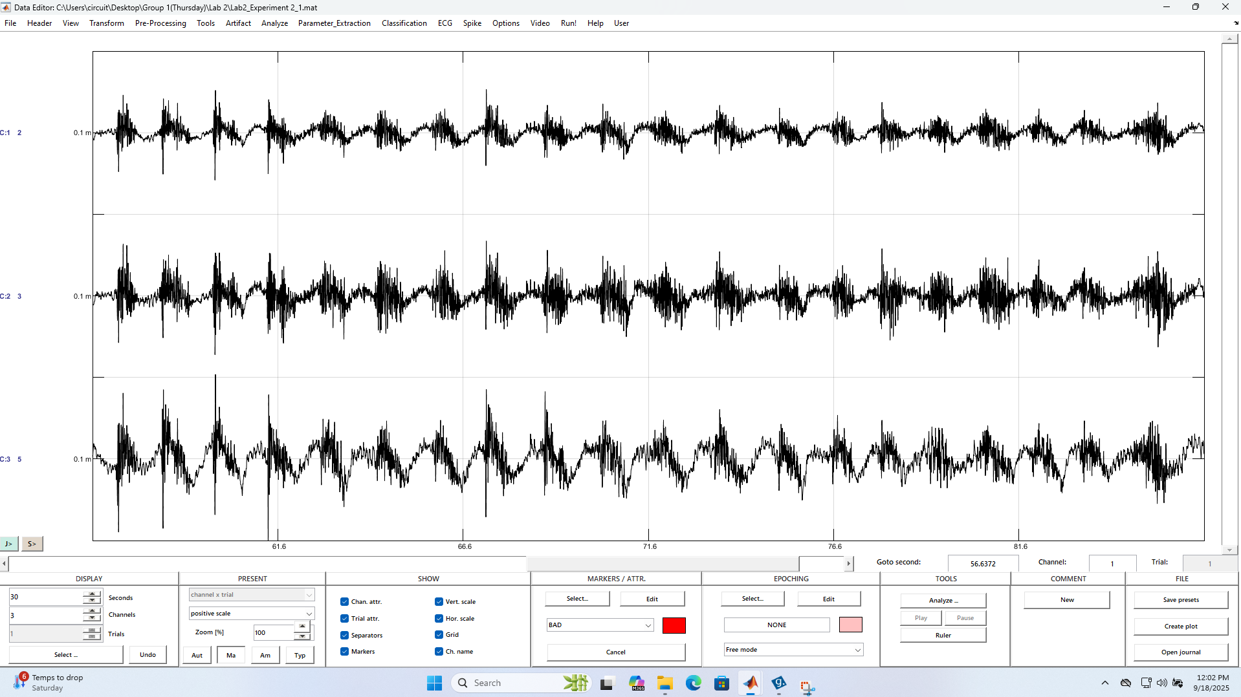
Figure 2.1.4 Chewing Bipolar Compared to Channel 3

Experiment 2.2: Bipolar vs monopolar (No filter)

Thomas Duan

